Request for Proposal (RFP) for Administration Professional Services - Cover Letter

02/02/2022

Re: Texas Department of Emergency Management (“TDEM”) Hazard Mitigation Grant Program (HMGP) program related to Texas Covid-19 Pandemic DR-4485-TX

Dear Service Providers:

Attached is a copy of the City’s Request for Proposals (“RFP”) for professional administration services. These services are being solicited to assist the City of Rose City in pre­award and post-award management services for Hazard Mitigation Grant Program (HMGP) contract(s), if awarded, from the Texas Division of Emergency Management (TDEM) for funding available from Texas Covid-19 Pandemic DR-4485-TX.

Service providers may submit proposals for any or all activities. Multiple contracts may be awarded as a result of this solicitation. The City will, in its sole discretion, determine the number of contracts awarded, and may decide not to award any contracts.

The submission requirements for this proposal are included in the attached RFP. Please submit a proposal of services and statement of qualifications to:

Dora Tarbox- City Secretary
Email address: rosecityhall@yahoo.com____________________________

The deadline for submission of proposals is February 17, 2022, at 2 pm. It is the responsibility of the submitting entity to ensure that the proposal is received in a timely manner. Proposals received after the deadline will not be considered for award, regardless of whether or not the delay was outside the control of the submitting provider. City of Rose City reserves the right to negotiate with any and all service providers submitting timely proposals.

City of Rose City is an Affirmative Action/Equal Opportunity Employer. Section 3 Residents, Minority Business Enterprises, Small Business Enterprises, Women Business Enterprises, and Labor Surplus Area firms are encouraged to submit proposals.

Sincerely,

__Dora Tarbox____________________
City Contact Person

RFP for Administration Professional Services

City of Rose City is seeking well-qualified administration/activity delivery service provider(s) to assist the City in preparing application(s) for and in the overall administration or implementation of proposed programs and/or projects financed through Texas Department of Emergency Management (“TDEM”) Hazard Mitigation Grant Program (HMGP) program related to Texas Covid-19 Pandemic DR-4485-TX. The following outlines the RFP:

- Scope of Work

Administration Services

A sample detailed Scope of Services for administration services provided is enclosed in this packet. The administration service provider to be hired will provide application and contract-related management services, including but not limited to the following areas:

Provider will administer and provide activity delivery eligible programs and eligible projects associated with HMGP funding. The selected service provider must follow all State and Federal requirements of the program

General Administration Services
- Needs Identification
- Program Design
- Recordkeeping and Reporting
- Contract Management
- Environmental Services
- Financial Management
- Construction Management
- Acquisition Duties (as necessary)
- Contract Closeout

Please specify a complete list of actual tasks to be performed under each of these categories in your response, including, if necessary, a brief description of each task.

- Statement of Qualifications

City is seeking qualified professional administration service providers experienced in the management of state and federal programs. Please provide the following as it relates to your qualifications:

- A brief history of the service provider, including general background, knowledge of and experience working with relevant agencies and programs;
- Related experience in managing federally funded local projects, in particular recent experience;
- A description of work performance and experience with similar projects including a list of at least three references from past local government clients, with information describing the relevancy of the previous performance.
- Describe which specific parts of the Scope of Work the service provider proposes to perform;
- Describe the capacity to perform the chosen Scope of Work activities as well as resumes of all employees who may be assigned to provide services if your firm is selected, identifying current employees and proposed hires; and
- A statement substantiating the resources of the service provider and the ability to carry out the scope of work requested within the proposed timeline.

- Proposed Cost of Services

Provide your cost proposal to accomplish the scope of work.

The local government will consider dividing total requirements, when economically feasible, into smaller tasks or quantities to permit maximum participation by small and minority businesses, and women’s business enterprises. As such, proposers may specify any maximum limit to the total dollar value of grant funds they are able and willing to manage. Service providers may submit proposals for any or all activities. Preference will be given to firm fixed pricing. The proposal must include all costs that are necessary to successfully complete these activities. Note that the lowest/best bid will not be used as the sole basis for entering into this contract; rather, award will be made to the service provider(s) providing the best value, cost and other factors considered.

Profit (either % / actual cost) must be identified and negotiated as a separate element of the price of the contract. To comply, the respondent must disclose and certify in its proposal the percentage of profit being used. “Cost plus percentage of cost” type proposals are prohibited.

- Evaluation Criteria - The proposal received will be evaluated and ranked according to the following criteria and using the rating sheet enclosed:
 | Criteria |  | Maximum  Points
 | Experience |  | 30
 | Work Performance |  | 30
 | Capacity to Perform |  | 20
 | Proposed Cost |  | 20
 | Total |  | 100

- Submission Requirements
- A copy of your current certificate of insurance for professional liability.
- Statement of Conflicts of Interest (if any) the service provider or key employees may have regarding these services, and a plan for mitigating the conflict(s). Note that City may in its sole discretion determine whether or not a conflict disqualifies a firm, and/or whether or not a conflict mitigation plan is acceptable.
- System for Award Management. Service provider and its Principals, may not be debarred or suspended nor otherwise on the Excluded Parties List System (EPLS) in the System for Award Management (SAM). Include verification that the service provider as well as the its principals are not listed (are not debarred) through the System for Award Management (www.SAM.gov). Enclose a print out of the search results that includes the record date.
- Form CIQ, (enclosed). Texas Local Government Code chapter 176 requires that any vendor or person who enters or seeks to enter into a contract with a local government entity disclose in the Questionnaire Form CIQ the vendor or person’s employment, affiliation, business relationship, family relationship or provision of gifts that might cause a conflict of interest with a local government entity. Questionnaire form CIQ is included in the RFP and must be submitted with the response.
- Certification Regarding Lobbying (enclosed). Certification for Contracts, Grants, Loans, and Cooperative Agreements is included in the RFP and must be submitted with the response.
- Form 1295, (enclosed). Effective January 1, 2016, all contracts and contract amendments, extensions, or renewals executed by the Commissioners Court will require the completion of Form 1295 “Certificate of Interested Parties” pursuant to Government Code § 2252.908. Form 1295 must be completed by awarded vendor at time of signed contract submission. Form 1295 is included in this RFP for your information.
- Required Contract Provisions. Applicable provisions (enclosed) must be included in all contracts executed as a result of this RFP.

- Contracting with small and minority businesses, women's business enterprises, and labor surplus area firms. Small and minority businesses, women's business enterprises, and labor surplus area firms are encouraged to participate in this RFP. If the awarded vendor is a prime contractor and may use subcontractors, the following affirmative steps are required of the prime contractor:
- Placing qualified small and minority businesses and women's business enterprises on solicitation lists;
- Assuring that small and minority businesses, and women's business enterprises are solicited whenever they are potential sources;
- Dividing total requirements, when economically feasible, into smaller tasks or quantities to permit maximum participation by small and minority businesses, and women's business enterprises;
- Establishing delivery schedules, where the requirement permits, which encourage participation by small and minority businesses, and women's business enterprises;
- Using the services and assistance, as appropriate, of such organizations as the Small Business Administration (SBA) and the Minority Business Development Agency (MBDA) of the Department of Commerce.

Minority-owned businesses may be eligible for contract procurement assistance with public and private sector entities from MBDA centers:

Houston MBDA Business Center
2302 Fannin Street, Suite 165, Houston, TX 77002
713-718-8974
https://www.hccs.edu/hcc-in-the-community/entrepreneurial-initiatives/mbda/

Dallas-Fort Worth MBDA Business Center
8828 N Stemmons Freeway - Ste 550-B, Dallas, TX 75247
214-920-2436
http://www.mbdadfw.com/

San Antonio MBDA Business Center
501 W César E Chávez Blvd, San Antonio, TX 78207
210-458-2480
https://sanantoniombdacenter.com/

MBDA Business Center – El Paso
c/o El Paso Hispanic Chamber of Commerce
2401 E.Missouri Ave.
El Paso, TX 79903
915-351-6232 ext. 19
https://ephcc.org/blog/growing-my-existing-business/our-mbda-business-center/

Small and woman-owned businesses may be eligible for assistance from SBA Women’s Business Centers:

Houston Women's Business Council, Inc.
9800 Northwest Freeway, Suite 120, Houston, TX 77018
713-681-9232
wbc@wbea-texas.org

LiftFund - Dallas Fort Worth Women's Business Center
8828 N. Stemmons Fwy, Suite 142, Dallas, TX 75247
888-215-2373
wbcdfw@liftfund.com

LiftFund - San Antonio Women's Business Center
600 Soledad St., San Antonio, TX 78205
888-215-2373
wbc@liftfund.com

SBA also provides assistance at Small Business Development Centers located across Texas:
https://americassbdc.org/small-business-consulting-and-training/find-your-sbdc/

- Deadline for Submission – Proposals must be received no later than February 17, 2022, 2 pm. It is the responsibility of the submitting entity to ensure that the proposal is received in a timely manner. Proposals received after the deadline will not be considered for award, regardless of whether or not the delay was outside the control of the submitting firm. Please submit an email of your proposal to rosecityhall@yahoo.com.

Any questions or requests for clarification must be submitted in writing via EMAIL to the address above at least 3 business days prior to the deadline. City may, if appropriate, circulate the question and answer to all service providers submitted proposals.

SCOPE OF SERVICES
Administration Services

The Contractor shall provide the following scope of services:

DESCRIPTION OF SERVICES AND SPECIAL CONDITIONS
Respondent must be able to perform the tasks listed herein to be considered eligible for an award under this Solicitation. Respondents should provide a detailed narrative of their experience as it relates to each of the items below. Respondents should clearly indicate if they intend to provide services in-house with existing staff or through subcontracting or partnership arrangements. Administration Services will be provided in conformance with the guidance documents and use forms provided by the subrecipient utilizing State and Federal guidance. The providers shall furnish post-funding administrative services to complete the HMGP projects, including, but not limited to the following:

Administration Services
- General Administrative Duties:
  - Ensure program compliance including all requirements and all parts therein, current Federal Register, etc.
  - Assist subrecipient in establishing and maintaining financial processes.
  - Obtain and maintain copies of the subrecipient’s most current contract including all related change requests, revisions and attachments.
  - Establish and maintain record keeping systems.
  - Assist subrecipient with resolving monitoring and audit findings.
  - Serve as monitoring liaison.
  - Assist subrecipient with resolving third party claims.
  - Report suspected fraud as applicable.
  - Submit timely responses to the State and Federal agencies requests for additional information.
.
- Facilitate outreach efforts, application intake, and eligibility review as applicable.

- Submit change requests and all required documentation related to any change requests.
- Coordinate, as necessary, between subrecipient and any other appropriate service providers (i.e. Engineer, Environmental, etc.), contractor, subcontractor to effectuate the services requested.
- May assist in public hearings.
- Will work with State and Federal agencies system of record as applicable.
- Provide monthly project status updates.
- Funding release will be based on deliverables identified in the contract.
- Labor and procurement duties:
  - Provide all Labor Standards Officer (LSO) Services.
  - Ensure compliance with all relevant labor standards regulations.
  - Ensure compliance with procurement regulations and policies.
  - Maintain document files to support compliance.
- Financial duties:
  - Prepare and submit all required reports (Section 3, Financial Interest, etc.).
  - Assist subrecipient with the procurement of audit services.
  - Assist subrecipient in establishing and maintaining a bank account for program funds.
  - Implementation and coordination of Section 504 requirements.
  - Program compliance.
  - Ensure that fraud prevention and abuse practices are in place and being implemented.
  - Prepare and submit all closeout documents.
  - Submit all invoices no later than 60 days after the expiration of the contract. All outstanding funds may be swept after 60 days. The provider may request an extension of this requirement in writing.
  - Assist in preparation of contract revisions and supporting documents including but not limited to:
    - Amendments/modifications,
    - Change orders.
- Perform any other administrative duty required to deliver the project.
- Construction Management
  - The provider will assist the subrecipient in submitting/setting up project.
  - The provider may compile and collate complete contract/bid packages that meet program requirements. The packages will contain supporting documentation that meets or exceeds the requirements of the program. If applications do not have the necessary forms, the provider may assist the subrecipient by coordinating to acquire the necessary documentation.
  - The provider may monitor, report, and evaluate contractor's performance; notify the subrecipient if the contractor(s) fails to meet established scheduled milestones. Receive, review, recommend, and process any change orders as appropriate to the individual projects.
  - The provider may assist the subrecipient with project Activity Draws/Close Out.
  - The provider may assist the subrecipient by submitting all the necessary documentation for project activity in the State and Federal agencies system of record.
  - The provider will compile, review for completeness, and collate complete contract/closeout packages that meet program requirements.
  - If applications do not have the necessary forms, the provider may assist the subrecipient by coordinating to acquire the necessary documentation.
  - The provider may assist the subrecipient in developing Architectural and Engineering plans
  - Reassignment scope alignment (if necessary).

- Acquisition Duties:
  - Submit acquisition reports and related documents
  - Determine need of acquisition and develop program to conduct acquisition services in line with the Uniform Relocation Act (URA).
  - Establish acquisition files (if necessary).
  - Complete acquisition activities (if necessary)

- Environmental Services
- ;
- Consult and coordinate with oversight/regulatory agencies to facilitate environmental clearance;
- Be able to perform or contract special studies, additional assessments, or permitting to secure environmental clearance. These may include, but are not limited to biological assessments, wetland delineations, asbestos surveys, lead-based paint assessments, archeology studies, architectural reviews, Phase I & II ESAs, USACE permits, etc.;
- Prepare all responses to comments received during comment phase of the environmental review, including State/Federal Agency requiring further studies and/or comments from public or private entities during public comment period;
- Maintain close coordination with local officials, project engineer and other members of the project team to assure appropriate level of environmental review is performed and no work is conducted without authorization;
- Complete and submit the environmental review into State and Federal agencies system of record;
- At least one site visit to project location and completion of a field observation report;
- Prepare and submit for publication all public notices including, but not limited to the Notice of Finding of No Significant Impact (FONSI), Request for Release of Funds floodplain/wetland early and final notices in required order and sequence;
- Provide documentation of clearance for Parties Known to be Interested as required by 24 CFR 58.43;
- Process environmental review and clearance in accordance with NEPA;
- Advise and complete environmental re-evaluations per 24 CFR 58.47 when evidence of further clearance or assessment is required;
- Prepare and submit Monthly Status Report; and
- Participate in regularly scheduled progress meetings.

Administration Professional Services Rating Sheet

Grant Recipient _______
Name of Respondent __________
Evaluator's Name _______ Date of Rating _________________
Rate the Respondent of the Request For Proposal (RFP) by awarding points up to the maximum listed for each factor. Information necessary to assess the Respondent on these criteria may be gathered either from past experience with the Respondent and/or by contacting past/current clients of the Respondent. Respondents proposing to offer specific services (environmental or buyout only) will be scored only on those services.
Experience
 | Factors | Max.Pts. |  | Score
1. | Related Experience / Background with federally funded projects | 5
2. | Related Experience / Background with specific project type (infrastructure, acquisition of property, coordination with regulatory agency, etc.) | 5
3. | Related experience/background with specific services:
 | - Administrative, construction management, and related acquisition | 5
 | - Environmental review | 5
 | - Buyout management (if not applicable score ‘0’) | 5
4. | References from current/past clients | 5
 | Subtotal, Experience | 30
Work Performance
 | Factors | Max.Pts. |  | Score
1. | Submits requests to client in a timely manner | 5
2. | Responds to client requests in a timely manner | 5
3. | Past client projects completed on schedule | 5
4. | Work product is consistently of high quality with low level of errors | 5
5. | Past client projects have low level of monitoring findings/concerns | 5
6. | Manages projects within budgetary constraints | 5
 | Subtotal, Performance | 30
Capacity to Perform
 | Factors | Max.Pts. |  | Score
1. | Qualifications / Experience of Staff
 | - Administrative, construction management, and related acquisition | 4
 | - Environmental review | 4
 | - Buyout management (if not applicable score ‘0’) | 4
2. | Present and Projected Workloads | 4
3. | Demonstrated understanding of scope of the HMGP | 4
 | Subtotal, Capacity to Perform | 20
Proposed Cost
 | Factors | Max.Pts. |  | Score
 | Proposed cost is in line with independent estimate and compared with all cost proposals received | 20
 | A = Lowest Proposal $__________ A ÷ B X 20 = Respondent’s Score  B = Respondent’s Proposal $__________ | 20
TOTAL SCORE
 | Factors | Max.Pts. |  | Score
◻ | Experience | 30
◻ | Work Performance | 30
◻ | Capacity to Perform | 20
◻ | Proposed Cost | 20
 | Total Score | 100

Insert Certificate of Insurance
Insert System for Award Management (SAM) record search for company name and company principal

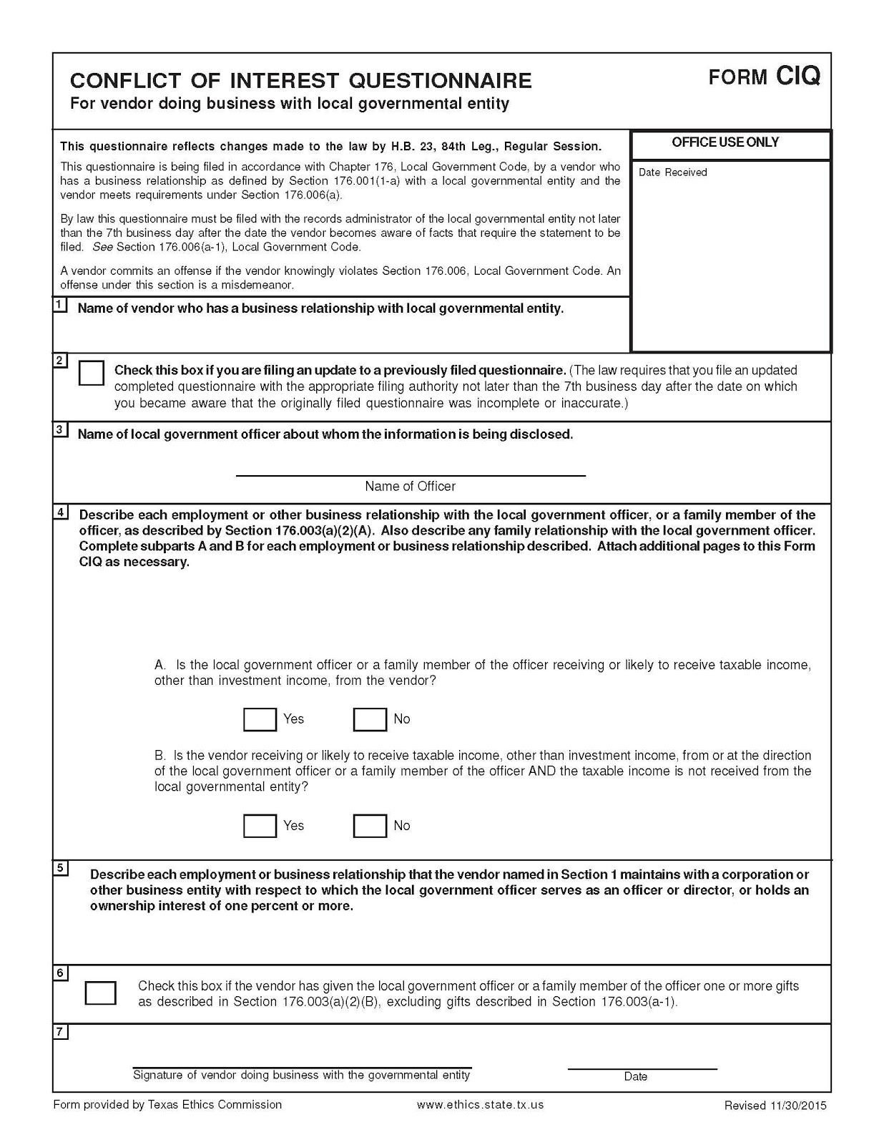
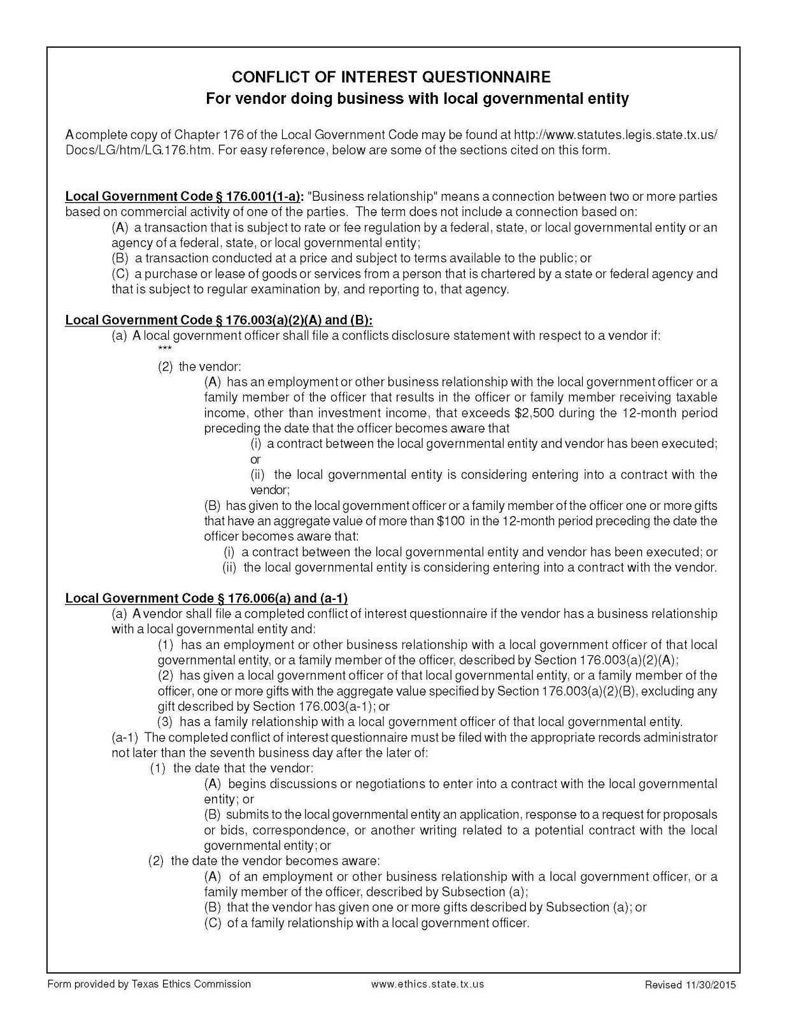
Certification Regarding Lobbying

(To be submitted with each bid or offer exceeding $100,000)

The undersigned certifies, to the best of his or her knowledge and belief, that:

(a) No Federal appropriated funds have been paid or will be paid, by or on behalf of the undersigned, to any person for influencing or attempting to influence an officer or employee of an agency, a Member of Congress, an officer or employee of Congress, or an employee of a Member of Congress in connection with the awarding of any Federal contract, the making of any Federal grant, the making of any Federal loan, the entering into of any cooperative agreement, and the extension, continuation, renewal, amendment, or modification of any Federal contract, grant, loan, or cooperative agreement.

(b) If any funds other than Federal appropriated funds have been paid or will be paid to any person for influencing or attempting to influence an officer or employee of any agency, a Member of Congress, an officer or employee of Congress, or an employee of a Member of Congress in connection with this Federal contract, grant, loan, or cooperative agreement, the undersigned shall complete and submit Standard Form-LLL, “Disclosure Form to Report Lobbying,” in accordance with its instructions.

(c) The undersigned shall require that the language paragraph 1 and 2 of this anti-lobbying certification be included in the award documents for all subawards at all tiers (including subcontracts, subgrants, and contracts under grants, loans, and cooperative agreements) and that all subrecipients shall certify and disclose accordingly.

This certification is a material representation of fact upon which reliance was placed when this transaction was made or entered into. Submission of this certification is a prerequisite for making or entering into this transaction imposed by 31, U.S.C. § 1352 (as amended by the Lobbying Disclosure Act of 1995).

The Contractor, ___________________, certifies or affirms the truthfulness and accuracy of each statement of its certification and disclosure, if any. In addition, the Contractor understands and agrees that the provisions of 31 U.S.C. § 3801 et seq., apply to this certification and disclosure, if any.

_____________________________________
Signature of Contractor’s Authorized Official

________________________________________________
Printed Name and Title of Contractor’s Authorized Official

_____________________________________
Date
INSTRUCTIONS FOR COMPLETION OF SF-LLL, DISCLOSURE OF LOBBYING ACTIVITIES

This disclosure form shall be completed by the reporting entity, whether subawardee or prime Federal recipient, at the initiation or receipt of a covered Federal action, or a material change to a previous filing, pursuant to title 31 U.S.C. section 1352. The filing of a form is required for each payment or agreement to make payment to any lobbying entity for influencing or attempting to influence an officer or employee of any agency, a Member of Congress, an officer or employee of Congress, or an employee of a Member of Congress in connection with a covered Federal action. Complete all items that apply for both the initial filing and material change report. Refer to the implementing guidance published by the Office of Management and Budget for additional information.

1. Identify the type of covered Federal action for which lobbying activity is and/or has been secured to influence the outcome of a covered Federal action.

2. Identify the status of the covered Federal action.

3. Identify the appropriate classification of this report. If this is a follow-up report caused by a material change to the information previously reported, enter the year and quarter in which the change occurred. Enter the date of the last previously submitted report by this reporting entity for this covered Federal action.

4. Enter the full name, address, city, State and zip code of the reporting entity. Include Congressional District, if known. Check the appropriate classification of the reporting entity that designates if it is, or expects to be, a prime or subaward recipient. Identify the tier of the subawardee, e.g., the first subawardee of the prime is the 1st tier. Subawards include but are not limited to subcontracts, subgrants and contract awards under grants.

5. If the organization filing the report in item 4 checks “Subawardee,” then enter the full name, address, city, State and zip code of the prime Federal recipient. Include Congressional District, if known.

6. Enter the name of the federal agency making the award or loan commitment. Include at least one organizational level below agency name, if known. For example, Department of Transportation, United States Coast Guard.

7. Enter the Federal program name or description for the covered Federal action (item 1). If known, enter the full Catalog of Federal Domestic Assistance (CFDA) number for grants, cooperative agreements, loans, and loan commitments.

8. Enter the most appropriate Federal identifying number available for the Federal action identified in item 1 (e.g., Request for Proposal (RFP) number; Invitations for Bid (IFB) number; grant announcement number; the contract, grant, or loan award number; the application/proposal control number assigned by the Federal agency). Included prefixes, e.g., “RFP-DE-90-001.”

9. For a covered Federal action where there has been an award or loan commitment by the Federal agency, enter the Federal amount of the award/loan commitment for the prime entity identified in item 4 or 5.

10. (a) Enter the full name, address, city, State and zip code of the lobbying registrant under the Lobbying Disclosure Act of 1995 engaged by the reporting entity identified in item 4 to influence the covered Federal action.

(b) Enter the full names of the individual(s) performing services, and include full address if different from 10(a). Enter Last Name, First Name, and Middle Initial (MI).

11. The certifying official shall sign and date the form, print his/her name, title, and telephone number.

According to the Paperwork Reduction Act, as amended, no persons are required to respond to a collection of information unless it displays a valid OMB control Number. The valid OMB control number for this information collection is OMB No. 0348-0046. Public reporting burden for this collection of information is estimated to average 10 minutes per response, including time for reviewing instructions, searching existing data sources, gathering and maintaining the data needed, and completing and reviewing the collection of information. Send comments regarding the burden estimate or any other aspect of this collection of information, including suggestions for reducing this burden, to the Office of Management and Budget, Paperwork Reduction Project (0348-0046), Washington, DC 20503

Approved by OMB
0348-0046
Disclosure of Lobbying Activities
Complete this form to disclose lobbying activities pursuant to 31 U.S.C. 1352
(See reverse for public burden disclosure)
Type of Federal Action:  a. contract  ____ b. grant  c. cooperative agreement  d. loan  e. loan guarantee  f. loan insurance | Status of Federal Action:  a. bid/offer/application  _____ b. initial award  c. post-award |  | Report Type:  a. initial filing  _____ b. material change
Name and Address of Reporting Entity:  ____ Prime _____ Subawardee  Tier______, if Known:  Congressional District, if known: |  | If Reporting Entity in No. 4 is Subawardee, Enter Name and Address of Prime:  Congressional District, if known:
Federal Department/Agency: |  | 7. Federal Program Name/Description:  CFDA Number, if applicable: __________________
Federal Action Number, if known: |  | 9. Award Amount, if known:  $
10. a. Name and Address of Lobbying Registrant  (if individual, last name, first name, MI): |  | b. Individuals Performing Services (including address if different from No. 10a)  (last name, first name, MI):
11. Information requested through this form is authorized by title 31 U.S.C. section 1352. This disclosure of lobbying activities is a material representation of fact upon which reliance was placed by the tier above when this transaction was made or entered into. This disclosure is required pursuant to 31 U.S.C. 1352. This information will be reported to the Congress semi-annually and will be available for public inspection. Any person who fails to file the required disclosure shall be subject to a civil penalty of not less than $10,000 and not more than $100,000 for each such failure. |  | Signature: __________________________________  Print Name: _____  Title: _____  Telephone No.: ____________ Date: _______
Federal Use Only |  | Authorized for Local Reproduction  Standard Form - LLL (Rev. 7-97)
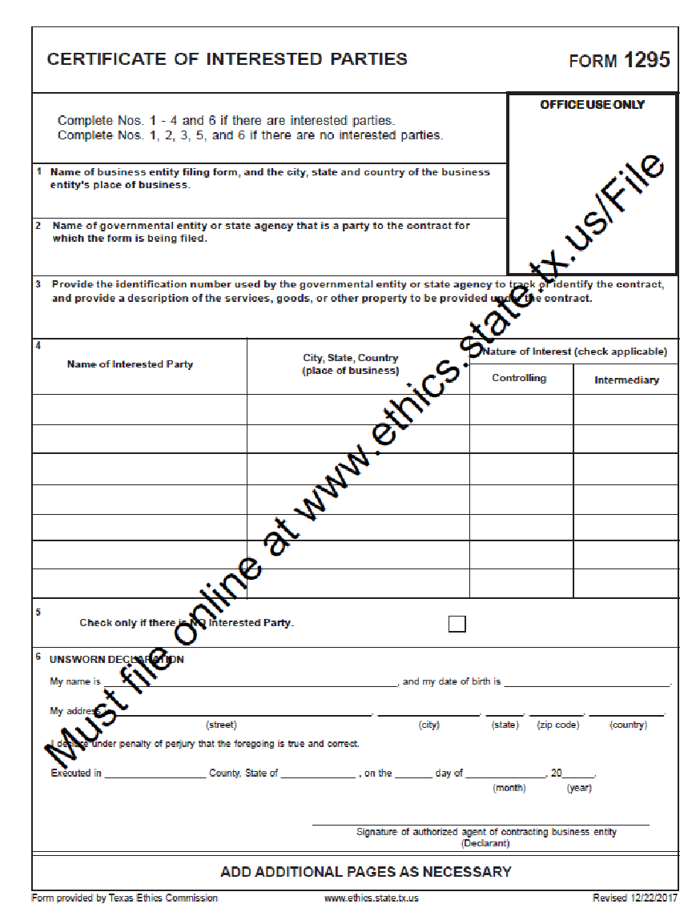
REQUIRED CONTRACT PROVISIONS
Italics – Explanatory; not contract language

All Contracts
THRESHOLD | PROVISION | CITATION
None | (H) Debarment and Suspension (Executive Orders 12549 and 12689)—A contract award (see 2 CFR 180.220) must not be made to parties listed on the government-wide Excluded Parties List System in the System for Award  Management (SAM), in accordance with the OMB guidelines at 2 CFR 180 that implement Executive Orders 12549 (3 CFR Part 1986 Comp., p. 189) and 12689 (3 CFR Part 1989  Comp., p. 235), ‘‘Debarment and Suspension.’’ SAM Exclusions contains the names of parties debarred, suspended, or otherwise excluded by agencies, as well as parties declared ineligible under statutory or regulatory authority other than Executive Order 12549. | 2 CFR 200  APPENDIX II (H)
None | The U.S. Department of Housing and Urban Development (HUD), Inspectors General, the Comptroller General of the United States, and the City/County, or any of their authorized representatives, shall have access to any documents, papers, or other records of the Contractor which are pertinent to the HMGP allocation, in order to make audits, examinations, excerpts, and transcripts and to closeout any City’s/County’s HMGP allocation. | 2 CFR 200.336 (former 24 CFR 85.36(i)(10))
None | HMGP recipients and subrecipients must retain all required records for three years after HMGP recipients and subrecipients make final payments and all other pending matters are closed. | 2 CFR 200.333 (former 24 CFR (85.36(i)(11))
None | Sec. 176.003. CONFLICTS DISCLOSURE STATEMENT REQUIRED.  (a) A local government officer shall file a conflicts disclosure statement with respect to a vendor if:  (1) the vendor enters into a contract with the local governmental entity or the local governmental entity is considering entering into a contract with the vendor; and  (2) the vendor:  (A) has an employment or other business relationship with the local government officer or a family member of the officer that results in the officer or family member receiving taxable income, other than investment income, that exceeds $2,500 during the 12-month period preceding the date that the officer becomes aware that:  (i) a contract between the local governmental entity and vendor has been executed; or  (ii) the local governmental entity is considering entering into a contract with the vendor;  (B) has given to the local government officer or a family member of the officer one or more gifts that have an aggregate value of more than $100 in the 12-month period preceding the date the officer becomes aware that:  (i) a contract between the local governmental entity and vendor has been executed; or  (ii) the local governmental entity is considering entering into a contract with the vendor; or has a family relationship with the local government officer.  (a-1) A local government officer is not required to file a conflicts disclosure statement in relation to a gift accepted by the officer or a family member of the officer if the gift is:  (1) a political contribution as defined by Title 15, Election Code; or  (2) food accepted as a guest.  (a-2) A local government officer is not required to file a conflicts disclosure statement under Subsection (a) if the local governmental entity or vendor described by that subsection is an administrative agency created under Section 791.013, Government Code.  (b) A local government officer shall file the conflicts disclosure statement with the records administrator of the local governmental entity not later than 5 p.m. on the seventh business day after the date on which the officer becomes aware of the facts that require the filing of the statement under Subsection (a). | Chapter 176 of the Local Government Code
>$10,000 | (B) All contracts in excess of $10,000 must address termination for cause and for convenience by the non-Federal entity including the manner by which it will be effected and the basis for settlement.  Use the following language for contracts > $ 10,000:  Termination for Cause  If the Contractor fails to fulfill in a timely and proper manner its obligations under this Agreement, or if the Contractor violates any of the covenants, conditions, agreements, or stipulations of this Agreement, the City/County shall have the right to terminate this Agreement by giving written notice to the Contractor of such termination and specifying the effective date thereof, which shall be at least five days before the effective date of such termination. In the event of termination for cause, all finished or unfinished documents, data, studies, surveys, drawings, maps, models, photographs and reports prepared by the Contractor pursuant to this Agreement shall, at the option of the City/County, be turned over to the City / County and become the property of the City / County. In the event of termination for cause, the Contractor shall be entitled to receive reasonable compensation for any necessary services actually and satisfactorily performed prior to the date of termination.  Notwithstanding the above, the Contractor shall not be relieved of liability to the City/County for damages sustained by the City/County by virtue of any breach of contract by the Contractor, and the City/County may set-off the damages it incurred as a result of the Contractor’s breach of contract from any amounts it might otherwise owe the Contractor.  Termination for Convenience of the City/County  City/County may at any time and for any reason terminate Contractor’s services and work at City/County's convenience upon providing written notice to the Contractor specifying the extent of termination and the effective date. Upon receipt of such notice, Contractor shall, unless the notice directs otherwise, immediately discontinue the work and placing of orders for materials, facilities and supplies in connection with the performance of this Agreement.  [Parties should include the manner by which such termination will be effected and the basis for settlement or any other terms and conditions concerning payment upon such termination.] | 2 CFR 200  APPENDIX II(B)
>$50,000 | (A) Contracts for more than $50,000 must address administrative, contractual, or legal remedies in instances where contractors violate or breach contract terms, and provide for such sanctions and penalties as appropriate.  Use the following language for contracts > $50,000:  Resolution of Program Non-compliance and Disallowed Costs  In the event of any dispute, claim, question, or disagreement arising from or relating to this Agreement, or the breach thereof, including determination of responsibility for any costs disallowed as a result of non-compliance with federal or state requirements, the parties hereto shall use their best efforts to settle the dispute, claim, question or disagreement. To this effect, the parties shall consult and negotiate with each other in good faith within 30 days of receipt of a written notice of the dispute or invitation to negotiate, and attempt to reach a just and equitable solution satisfactory to both parties. If the matter is not resolved by negotiation within 30 days of receipt of written notice or invitation to negotiate, the parties agree first to try in good faith to settle the matter by mediation administered by the American Arbitration Association under its Commercial Mediation Procedures before resorting to arbitration, litigation, or some other dispute resolution procedure. The parties may enter into a written amendment to this Agreement and choose a mediator that is not affiliated with the American Arbitration Association. The parties shall bear the costs of such mediation equally. [This section may also provide for the qualifications of the mediator(s), the locale of meetings, time limits, or any other item of concern to the parties.] If the matter is not resolved through such mediation within 60 days of the initiation of that procedure, either party may proceed to file suit. | 2 CFR 200  APPENDIX II (A)
Option Contract Language for Procurement before Grant Funds Awarded | Payment of the fees [described in ____ section] shall be contingent on HMGP allocations. In the event that an allocation is not distributed to the City / County by the State or U.S. Department of Treasury, this agreement shall be terminated by the City / County. | 2 CFR 200.319(a)

Additional provisions for administration & engineering contracts associated with construction contracts
THRESHOLD | PROVISION | CITATION
>$10,000 | (Italics – Explanatory; not contract language)  2 CFR 200 Appendix II (C) Equal Employment Opportunity. Except as otherwise provided under 41 CFR Part 60, all contracts that meet the definition of ‘‘federally assisted construction contract’’ in 41 CFR Part 60–1.3 must include the equal opportunity clause provided under 41 CFR 60–1.4(b), in accordance with Executive Order 11246, ‘‘Equal Employment Opportunity’’ (30 FR 12319, 12935, 3 CFR Part, 1964–1965 Comp., p. 339), as amended by Executive Order 11375, ‘‘Amending Executive Order 11246 Relating to Equal Employment Opportunity,’’ and implementing regulations at 41 CFR part 60, ‘‘Office of Federal Contract Compliance Programs, Equal Employment Opportunity, Department of Labor.’’  Therefore, include the following EO clause (not in italics) in construction contracts including construction associated administration and engineering contracts > $10,000:  §60-1.4(b) Equal opportunity clause.  (b) Federally assisted construction contracts. Except as otherwise provided, each administering agency shall require the inclusion of the following language as a condition of any grant, contract, loan, insurance, or guarantee involving federally assisted construction which is not exempt from the requirements of the equal opportunity clause:  The applicant hereby agrees that it will incorporate or cause to be incorporated into any contract for construction work, or modification thereof, as defined in the regulations of the Secretary of Labor at 41 CFR chapter 60, which is paid for in whole or in part with funds obtained from the Federal Government or borrowed on the credit of the Federal Government pursuant to a grant, contract, loan insurance, or guarantee, or undertaken pursuant to any Federal program involving such grant, contract, loan, insurance, or guarantee, the following equal opportunity clause:  During the performance of this contract, the contractor agrees as follows:  (1) The contractor will not discriminate against any employee or applicant for employment because of race, color, religion, sex, sexual orientation, gender identity, or national origin. The contractor will take affirmative action to ensure that applicants are employed, and that employees are treated during employment without regard to their race, color, religion, sex, sexual orientation, gender identity, or national origin. Such action shall include, but not be limited to the following: Employment, upgrading, demotion, or transfer; recruitment or recruitment advertising; layoff or termination; rates of pay or other forms of compensation; and selection for training, including apprenticeship. The contractor agrees to post in conspicuous places, available to employees and applicants for employment, notices to be provided setting forth the provisions of this nondiscrimination clause.  (2) The contractor will, in all solicitations or advertisements for employees placed by or on behalf of the contractor, state that all qualified applicants will receive considerations for employment without regard to race, color, religion, sex, sexual orientation, gender identity, or national origin.  (3) The Contractor will not discourage or in any other manner discriminate against any employee or applicant for employment because such employee or applicant has inquired about, discussed, or disclosed the compensation of the employee or applicant or another employee or applicant. This provision shall not apply to instances in which an employee who has access to the compensation information of other employees or applicants as a part of such employee’s essential job functions discloses the compensation of such other employees or applicants to individuals who do not otherwise have access to such information, unless such disclosure is in response to a formal complaint or charge, in furtherance of an investigation, proceeding, hearing, or action, including an investigation conducted by the employer, or is consistent with the contractor’s legal duty to furnish information.  (4) The contractor will send to each labor union or representative of workers with which he has a collective bargaining agreement or other contract or understanding, a notice to be provided advising the said labor union or workers' representatives of the contractor's commitments under this section, and shall post copies of the notice in conspicuous places available to employees and applicants for employment.  (5) The contractor will comply with all provisions of Executive Order 11246 of September 24, 1965, and of the rules, regulations, and relevant orders of the Secretary of Labor.  (6) The contractor will furnish all information and reports required by Executive Order 11246 of September 24, 1965, and by rules, regulations, and orders of the Secretary of Labor, or pursuant thereto, and will permit access to his books, records, and accounts by the administering agency and the Secretary of Labor for purposes of investigation to ascertain compliance with such rules, regulations, and orders.  (7) In the event of the contractor's noncompliance with the nondiscrimination clauses of this contract or with any of the said rules, regulations, or orders, this contract may be canceled, terminated, or suspended in whole or in part and the contractor may be declared ineligible for further Government contracts or federally assisted construction contracts in accordance with procedures authorized in Executive Order 11246 of September 24, 1965, and such other sanctions may be imposed and remedies invoked as provided in Executive Order 11246 of September 24, 1965, or by rule, regulation, or order of the Secretary of Labor, or as otherwise provided by law.  (8) The contractor will include the portion of the sentence immediately preceding paragraph (1) and the provisions of paragraphs (1) through (7) in every subcontract or purchase order unless exempted by rules, regulations, or orders of the Secretary of Labor issued pursuant to section 204 of Executive Order 11246 of September 24, 1965, so that such provisions will be binding upon each subcontractor or vendor. The contractor will take such action with respect to any subcontract or purchase order as the administering agency may direct as a means of enforcing such provisions, including sanctions for noncompliance: Provided, however, That in the event a contractor becomes involved in, or is threatened with, litigation with a subcontractor or vendor as a result of such direction by the administering agency the contractor may request the United States to enter into such litigation to protect the interests of the United States.  The applicant further agrees that it will be bound by the above equal opportunity clause with respect to its own employment practices when it participates in federally assisted construction work: Provided, That if the applicant so participating is a State or local government, the above equal opportunity clause is not applicable to any agency, instrumentality or subdivision of such government which does not participate in work on or under the contract.  The applicant agrees that it will assist and cooperate actively with the administering agency and the Secretary of Labor in obtaining the compliance of contractors and subcontractors with the equal opportunity clause and the rules, regulations, and relevant orders of the Secretary of Labor, that it will furnish the administering agency and the Secretary of Labor such information as they may require for the supervision of such compliance, and that it will otherwise assist the administering agency in the discharge of the agency's primary responsibility for securing compliance.  The applicant further agrees that it will refrain from entering into any contract or contract modification subject to Executive Order 11246 of September 24, 1965, with a contractor debarred from, or who has not demonstrated eligibility for, Government contracts and federally assisted construction contracts pursuant to the Executive order and will carry out such sanctions and penalties for violation of the equal opportunity clause as may be imposed upon contractors and subcontractors by the administering agency or the Secretary of Labor pursuant to Part II, Subpart D of the Executive order. In addition, the applicant agrees that if it fails or refuses to comply with these undertakings, the administering agency may take any or all of the following actions: Cancel, terminate, or suspend in whole or in part this grant (contract, loan, insurance, guarantee); refrain from extending any further assistance to the applicant under the program with respect to which the failure or refund occurred until satisfactory assurance of future compliance has been received from such applicant; and refer the case to the Department of Justice for appropriate legal proceedings.  (c) Subcontracts. Each nonexempt prime contractor or subcontractor shall include the equal opportunity clause in each of its nonexempt subcontracts.  (d) Incorporation by reference. The equal opportunity clause may be incorporated by reference in all Government contracts and subcontracts, including Government bills of lading, transportation requests, contracts for deposit of Government funds, and contracts for issuing and paying U.S. savings bonds and notes, and such other contracts and subcontracts as the Deputy Assistant Secretary may designate.  (e) Incorporation by operation of the order. By operation of the order, the equal opportunity clause shall be considered to be a part of every contract and subcontract required by the order and the regulations in this part to include such a clause whether or not it is physically incorporated in such contracts and whether or not the contract between the agency and the contractor is written.  (f) Adaptation of language. Such necessary changes in language may be made in the equal opportunity clause as shall be appropriate to identify properly the parties and their undertakings.  [43 FR 49240, Oct. 20, 1978, as amended at 62 FR 66971, Dec. 22, 1997; 79 FR 72993, Dec. 9, 2014; 80 FR 54934, September 11, 2015] | 41 CFR §60-1.4(b)  And  2 CFR 200  APPENDIX II (C)
>$100,000 | §135.38 Section 3 clause  All section 3 covered contracts shall include the following clause (referred to as the section 3 clause):  A. The work to be performed under this contract is subject to the requirements of section 3 of the Housing and Urban Development Act of 1968, as amended, 12 U.S.C. 1701u  (Section 3). The purpose of section 3 is to ensure that employment and other economic opportunities generated by HUD assistance or HUD-assisted projects covered by section 3, shall, to the greatest extent feasible, be directed  to low- and very low-income persons, particularly persons who are recipients of HUD assistance for housing.  B. The parties to this contract agree to comply with HUD’s regulations in 24 CFR part 135, which implement section 3. As evidenced by their execution of this contract, the parties to this contract certify that they are under no contractual or other impediment that would prevent them from complying  with the part 135 regulations.  C. The contractor agrees to send to each labor organization or representative of workers with which the contractor has a collective bargaining agreement or other understanding,  if any, a notice advising the labor organization or workers’ representative of the contractor’s commitments under this  section 3 clause, and will post copies of the notice in conspicuous places at the work site where both employees and applicants for training and employment positions can see the notice. The notice shall describe the section 3 preference, shall set forth minimum number and job titles subject to hire, availability of apprenticeship and training positions, the qualifications for each; and the name and location of the person(s) taking applications for each of the positions; and the anticipated date the work shall begin.  D. The contractor agrees to include this section 3 clause in every subcontract subject to compliance with regulations in 24 CFR part 135, and agrees to take appropriate action,  as provided in an applicable provision of the subcontract or in this section 3 clause, upon a finding that the subcontractor is in violation of the regulations in 24 CFR part  135. The contractor will not subcontract with any subcontractor where the contractor has notice or knowledge that the subcontractor has been found in violation of the regulations in 24 CFR part 135.  E. The contractor will certify that any vacant employment positions, including training positions, that are filled (1) after the contractor is selected but before the contract is  executed, and (2) with persons other than those to whom the regulations of 24 CFR part 135 require employment opportunities to be directed, were not filled to circumvent  the contractor’s obligations under 24 CFR part 135.  F. Noncompliance with HUD’s regulations in 24 CFR part 135 may result in sanctions, termination of this contract for default, and debarment or suspension from future HUD  assisted contracts.  G. With respect to work performed in connection  with section 3 covered Indian housing assistance, section 7(b) of the Indian Self-Determination and Education Assistance Act (25 U.S.C. 450e) also applies to the work to be performed under this contract. Section 7(b) requires that to the greatest extent feasible (i) preference and opportunities for training and employment shall be given  to Indians, and (ii) preference in the award of contracts and subcontracts shall be given to Indian organizations and Indian-owned Economic Enterprises. Parties to this contract  that are subject to the provisions of section 3 and section 7(b) agree to comply with section 3 to the maximum extent feasible, but not in derogation of compliance with section 7(b). | 24 CFR §135.38

Construction Contracts
THRESHOLD | PROVISION | CITATION
>$2,000 for Davis Bacon and Copeland “Anti-Kickback” Act;  >$100,000 for Contract Work Hours and Safety Standards Act | HUD 4010 Federal labor standards provisions include:  - Davis Bacon Act (40 U.S.C. 3141 et seq.) as supplemented by DOL regulations (29 CFR part 5);  - Copeland “Anti-Kickback” Act (40 U.S.C. 3145), as supplemented by Department of Labor regulations (29 CFR Part 3); and  - Contract Work Hours and Safety Standards Act (40 U.S.C. 3701 et seq.)  See HUD 4010 contract language in Appendix F. Inclusion of this language into the construction contract satisfies contract requirements of the separate acts noted.
>$2,000  (Satisfied with inclusion of HUD 4010) | Compliance with the Davis-Bacon Act (40 U.S.C. 3141 et seq.) as supplemented by Department of Labor regulations (29 CFR part 5) and with the Copeland “Anti-Kickback” Act (18 U.S.C. 874; 40 U.S.C. 3145) as supplemented in Department of Labor regulations (29 CFR part 3):  (D) Davis-Bacon Act, as amended (40 U.S.C. 3141-3148). When required by Federal program legislation, all prime construction contracts in excess of $2,000 awarded by non-Federal entities must include a provision for compliance with the Davis-Bacon Act (40 U.S.C. 3141-3144, and 3146-3148) as supplemented by Department of Labor regulations (29 CFR Part 5, “Labor Standards Provisions Applicable to Contracts Covering Federally Financed and Assisted Construction”). In accordance with the statute, contractors must be required to pay wages to laborers and mechanics at a rate not less than the prevailing wages specified in a wage determination made by the Secretary of Labor. In addition, contractors must be required to pay wages not less than once a week. The non-Federal entity must place a copy of the current prevailing wage determination issued by the Department of Labor in each solicitation. The decision to award a contract or subcontract must be conditioned upon the acceptance of the wage determination. The non-Federal entity must report all suspected or reported violations to the Federal awarding agency. The contracts must also include a provision for compliance with the Copeland “Anti-Kickback” Act (40 U.S.C. 3145), as supplemented by Department of Labor regulations (29 CFR Part 3, “Contractors and Subcontractors on Public Building or Public Work Financed in Whole or in Part by Loans or Grants from the United States”). The Act provides that each contractor or subrecipient must be prohibited from inducing, by any means, any person employed in the construction, completion, or repair of public work, to give up any part of the compensation to which he or she is otherwise entitled. The non-Federal entity must report all suspected or reported violations to the Federal awarding agency. | 2 CFR 200  APPENDIX II (D)
>$10,000 | (Italics – Explanatory; not contract language)  2 CFR 200 Appendix II (C) Equal Employment Opportunity. Except as otherwise provided under 41 CFR Part 60, all contracts that meet the definition of ‘‘federally assisted construction contract’’ in 41 CFR Part 60–1.3 must include the equal opportunity clause provided under 41 CFR 60–1.4(b), in accordance with Executive Order 11246, ‘‘Equal Employment Opportunity’’ (30 FR 12319, 12935, 3 CFR Part, 1964–1965 Comp., p. 339), as amended by Executive Order 11375, ‘‘Amending Executive Order 11246 Relating to Equal Employment Opportunity,’’ and implementing regulations at 41 CFR part 60, ‘‘Office of Federal Contract Compliance Programs, Equal Employment Opportunity, Department of Labor.’’  Therefore, include the following EO clause (not in italics) in construction contracts including construction associated administration and engineering contracts > $10,000:  §60-1.4(b) Equal opportunity clause.  (b) Federally assisted construction contracts. Except as otherwise provided, each administering agency shall require the inclusion of the following language as a condition of any grant, contract, loan, insurance, or guarantee involving federally assisted construction which is not exempt from the requirements of the equal opportunity clause:  The applicant hereby agrees that it will incorporate or cause to be incorporated into any contract for construction work, or modification thereof, as defined in the regulations of the Secretary of Labor at 41 CFR chapter 60, which is paid for in whole or in part with funds obtained from the Federal Government or borrowed on the credit of the Federal Government pursuant to a grant, contract, loan insurance, or guarantee, or undertaken pursuant to any Federal program involving such grant, contract, loan, insurance, or guarantee, the following equal opportunity clause:  During the performance of this contract, the contractor agrees as follows:  (1) The contractor will not discriminate against any employee or applicant for employment because of race, color, religion, sex, sexual orientation, gender identity, or national origin. The contractor will take affirmative action to ensure that applicants are employed, and that employees are treated during employment without regard to their race, color, religion, sex, sexual orientation, gender identity, or national origin. Such action shall include, but not be limited to the following: Employment, upgrading, demotion, or transfer; recruitment or recruitment advertising; layoff or termination; rates of pay or other forms of compensation; and selection for training, including apprenticeship. The contractor agrees to post in conspicuous places, available to employees and applicants for employment, notices to be provided setting forth the provisions of this nondiscrimination clause.  (2) The contractor will, in all solicitations or advertisements for employees placed by or on behalf of the contractor, state that all qualified applicants will receive considerations for employment without regard to race, color, religion, sex, sexual orientation, gender identity, or national origin.  (3) The Contractor will not discourage or in any other manner discriminate against any employee or applicant for employment because such employee or applicant has inquired about, discussed, or disclosed the compensation of the employee or applicant or another employee or applicant. This provision shall not apply to instances in which an employee who has access to the compensation information of other employees or applicants as a part of such employee’s essential job functions discloses the compensation of such other employees or applicants to individuals who do not otherwise have access to such information, unless such disclosure is in response to a formal complaint or charge, in furtherance of an investigation, proceeding, hearing, or action, including an investigation conducted by the employer, or is consistent with the contractor’s legal duty to furnish information.  (4) The contractor will send to each labor union or representative of workers with which he has a collective bargaining agreement or other contract or understanding, a notice to be provided advising the said labor union or workers' representatives of the contractor's commitments under this section, and shall post copies of the notice in conspicuous places available to employees and applicants for employment.  (5) The contractor will comply with all provisions of Executive Order 11246 of September 24, 1965, and of the rules, regulations, and relevant orders of the Secretary of Labor.  (6) The contractor will furnish all information and reports required by Executive Order 11246 of September 24, 1965, and by rules, regulations, and orders of the Secretary of Labor, or pursuant thereto, and will permit access to his books, records, and accounts by the administering agency and the Secretary of Labor for purposes of investigation to ascertain compliance with such rules, regulations, and orders.  (7) In the event of the contractor's noncompliance with the nondiscrimination clauses of this contract or with any of the said rules, regulations, or orders, this contract may be canceled, terminated, or suspended in whole or in part and the contractor may be declared ineligible for further Government contracts or federally assisted construction contracts in accordance with procedures authorized in Executive Order 11246 of September 24, 1965, and such other sanctions may be imposed and remedies invoked as provided in Executive Order 11246 of September 24, 1965, or by rule, regulation, or order of the Secretary of Labor, or as otherwise provided by law.  (8) The contractor will include the portion of the sentence immediately preceding paragraph (1) and the provisions of paragraphs (1) through (7) in every subcontract or purchase order unless exempted by rules, regulations, or orders of the Secretary of Labor issued pursuant to section 204 of Executive Order 11246 of September 24, 1965, so that such provisions will be binding upon each subcontractor or vendor. The contractor will take such action with respect to any subcontract or purchase order as the administering agency may direct as a means of enforcing such provisions, including sanctions for noncompliance: Provided, however, That in the event a contractor becomes involved in, or is threatened with, litigation with a subcontractor or vendor as a result of such direction by the administering agency the contractor may request the United States to enter into such litigation to protect the interests of the United States.  The applicant further agrees that it will be bound by the above equal opportunity clause with respect to its own employment practices when it participates in federally assisted construction work: Provided, That if the applicant so participating is a State or local government, the above equal opportunity clause is not applicable to any agency, instrumentality or subdivision of such government which does not participate in work on or under the contract.  The applicant agrees that it will assist and cooperate actively with the administering agency and the Secretary of Labor in obtaining the compliance of contractors and subcontractors with the equal opportunity clause and the rules, regulations, and relevant orders of the Secretary of Labor, that it will furnish the administering agency and the Secretary of Labor such information as they may require for the supervision of such compliance, and that it will otherwise assist the administering agency in the discharge of the agency's primary responsibility for securing compliance.  The applicant further agrees that it will refrain from entering into any contract or contract modification subject to Executive Order 11246 of September 24, 1965, with a contractor debarred from, or who has not demonstrated eligibility for, Government contracts and federally assisted construction contracts pursuant to the Executive order and will carry out such sanctions and penalties for violation of the equal opportunity clause as may be imposed upon contractors and subcontractors by the administering agency or the Secretary of Labor pursuant to Part II, Subpart D of the Executive order. In addition, the applicant agrees that if it fails or refuses to comply with these undertakings, the administering agency may take any or all of the following actions: Cancel, terminate, or suspend in whole or in part this grant (contract, loan, insurance, guarantee); refrain from extending any further assistance to the applicant under the program with respect to which the failure or refund occurred until satisfactory assurance of future compliance has been received from such applicant; and refer the case to the Department of Justice for appropriate legal proceedings.  (c) Subcontracts. Each nonexempt prime contractor or subcontractor shall include the equal opportunity clause in each of its nonexempt subcontracts.  (d) Incorporation by reference. The equal opportunity clause may be incorporated by reference in all Government contracts and subcontracts, including Government bills of lading, transportation requests, contracts for deposit of Government funds, and contracts for issuing and paying U.S. savings bonds and notes, and such other contracts and subcontracts as the Deputy Assistant Secretary may designate.  (e) Incorporation by operation of the order. By operation of the order, the equal opportunity clause shall be considered to be a part of every contract and subcontract required by the order and the regulations in this part to include such a clause whether or not it is physically incorporated in such contracts and whether or not the contract between the agency and the contractor is written.  (f) Adaptation of language. Such necessary changes in language may be made in the equal opportunity clause as shall be appropriate to identify properly the parties and their undertakings.  [43 FR 49240, Oct. 20, 1978, as amended at 62 FR 66971, Dec. 22, 1997; 79 FR 72993, Dec. 9, 2014; 80 FR 54934, September 11, 2015] | 41 CFR §60-1.4(b)  And  2 CFR 200  APPENDIX II (C)
≥$100,000 | (I) Byrd Anti-Lobbying Amendment (31 U.S.C. 1352)—Contractors that apply or bid for an award of $100,000 or more must file the required certification. Each tier certifies to  the tier above that it will not and has not used Federal appropriated funds to pay any person or organization for influencing or attempting to influence an officer or employee  of any agency, a member of Congress, officer or employee of Congress, or an employee of a member of Congress in connection with obtaining any Federal contract, grant or any other award covered by 31 U.S.C. 1352. Each tier must also disclose any lobbying with non-Federal funds that takes place in connection with obtaining any Federal award.  Such disclosures are forwarded from tier to tier up to the non-Federal award. | 2 CFR 200  APPENDIX II (I)  and  24 CFR §570.303
>$100,000  (Satisfied with inclusion of HUD 4010) | (E) Contract Work Hours and Safety Standards Act (40 U.S.C. 3701–3708). Where applicable, all contracts awarded by the non-Federal entity in excess of $100,000 that involve the employment of mechanics or laborers  must include a provision for compliance with 40 U.S.C. 3702 and 3704, as supplemented by Department of Labor regulations (29 CFR Part 5). Under 40 U.S.C. 3702 of the Act, each contractor must be required to compute the  wages of every mechanic and laborer on the basis of a standard work week of 40 hours. Work in excess of the standard work week is permissible provided that the worker is compensated at a rate of not less than one and a half times the basic rate of pay for all hours worked in excess of 40 hours in the work week. The requirements of 40 U.S.C. 3704 are applicable to construction work and provide that no laborer or mechanic must be required to work in surroundings or under working conditions which are unsanitary, hazardous or dangerous. These requirements  do not apply to the purchases of supplies or materials or articles ordinarily available on the open market, or contracts for transportation or transmission of intelligence. | 2 CFR 200  APPENDIX II (E)
>$100,000 | §135.38 Section 3 clause  All section 3 covered contracts shall include the following clause (referred to as the section 3 clause):  A. The work to be performed under this contract is subject to the requirements of section 3 of the Housing and Urban Development Act of 1968, as amended, 12 U.S.C. 1701u  (Section 3). The purpose of section 3 is to ensure that employment and other economic opportunities generated by HUD assistance or HUD-assisted projects covered by section 3, shall, to the greatest extent feasible, be directed  to low- and very low-income persons, particularly persons who are recipients of HUD assistance for housing.  B. The parties to this contract agree to comply with HUD’s regulations in 24 CFR part 135, which implement section 3. As evidenced by their execution of this contract, the parties to this contract certify that they are under no contractual or other impediment that would prevent them from complying  with the part 135 regulations.  C. The contractor agrees to send to each labor organization or representative of workers with which the contractor has a collective bargaining agreement or other understanding,  if any, a notice advising the labor organization or workers’ representative of the contractor’s commitments under this  section 3 clause, and will post copies of the notice in conspicuous places at the work site where both employees and applicants for training and employment positions can see the notice. The notice shall describe the section 3 preference, shall set forth minimum number and job titles subject to hire, availability of apprenticeship and training positions, the qualifications for each; and the name and location of the person(s) taking applications for each of the positions; and the anticipated date the work shall begin.  D. The contractor agrees to include this section 3 clause in every subcontract subject to compliance with regulations in 24 CFR part 135, and agrees to take appropriate action,  as provided in an applicable provision of the subcontract or in this section 3 clause, upon a finding that the subcontractor is in violation of the regulations in 24 CFR part  135. The contractor will not subcontract with any subcontractor where the contractor has notice or knowledge that the subcontractor has been found in violation of the regulations in 24 CFR part 135.  E. The contractor will certify that any vacant employment positions, including training positions, that are filled (1) after the contractor is selected but before the contract is  executed, and (2) with persons other than those to whom the regulations of 24 CFR part 135 require employment opportunities to be directed, were not filled to circumvent  the contractor’s obligations under 24 CFR part 135.  F. Noncompliance with HUD’s regulations in 24 CFR part 135 may result in sanctions, termination of this contract for default, and debarment or suspension from future HUD  assisted contracts.  G. With respect to work performed in connection  with section 3 covered Indian housing assistance, section 7(b) of the Indian Self-Determination and Education Assistance Act (25 U.S.C. 450e) also applies to the work to be performed under this contract. Section 7(b) requires that to the greatest extent feasible (i) preference and opportunities for training and employment shall be given  to Indians, and (ii) preference in the award of contracts and subcontracts shall be given to Indian organizations and Indian-owned Economic Enterprises. Parties to this contract  that are subject to the provisions of section 3 and section 7(b) agree to comply with section 3 to the maximum extent feasible, but not in derogation of compliance with section 7(b). | 24 CFR §135.38
>$150,000 | (G) Clean Air Act (42 U.S.C. 7401–7671q.) and the Federal Water Pollution Control Act (33 U.S.C. 1251–1387), as amended—Contracts and subgrants of amounts in excess of $150,000 must contain a provision that requires the  non-Federal award to agree to comply with all applicable standards, orders or regulations issued pursuant to the Clean Air Act (42 U.S.C. 7401–7671q) and the Federal Water Pollution Control Act as amended (33 U.S.C. 1251–1387). Violations must be reported to the Federal awarding agency and the Regional Office of the Environmental Protection Agency (EPA). | 2 CFR 200  APPENDIX II (G)

